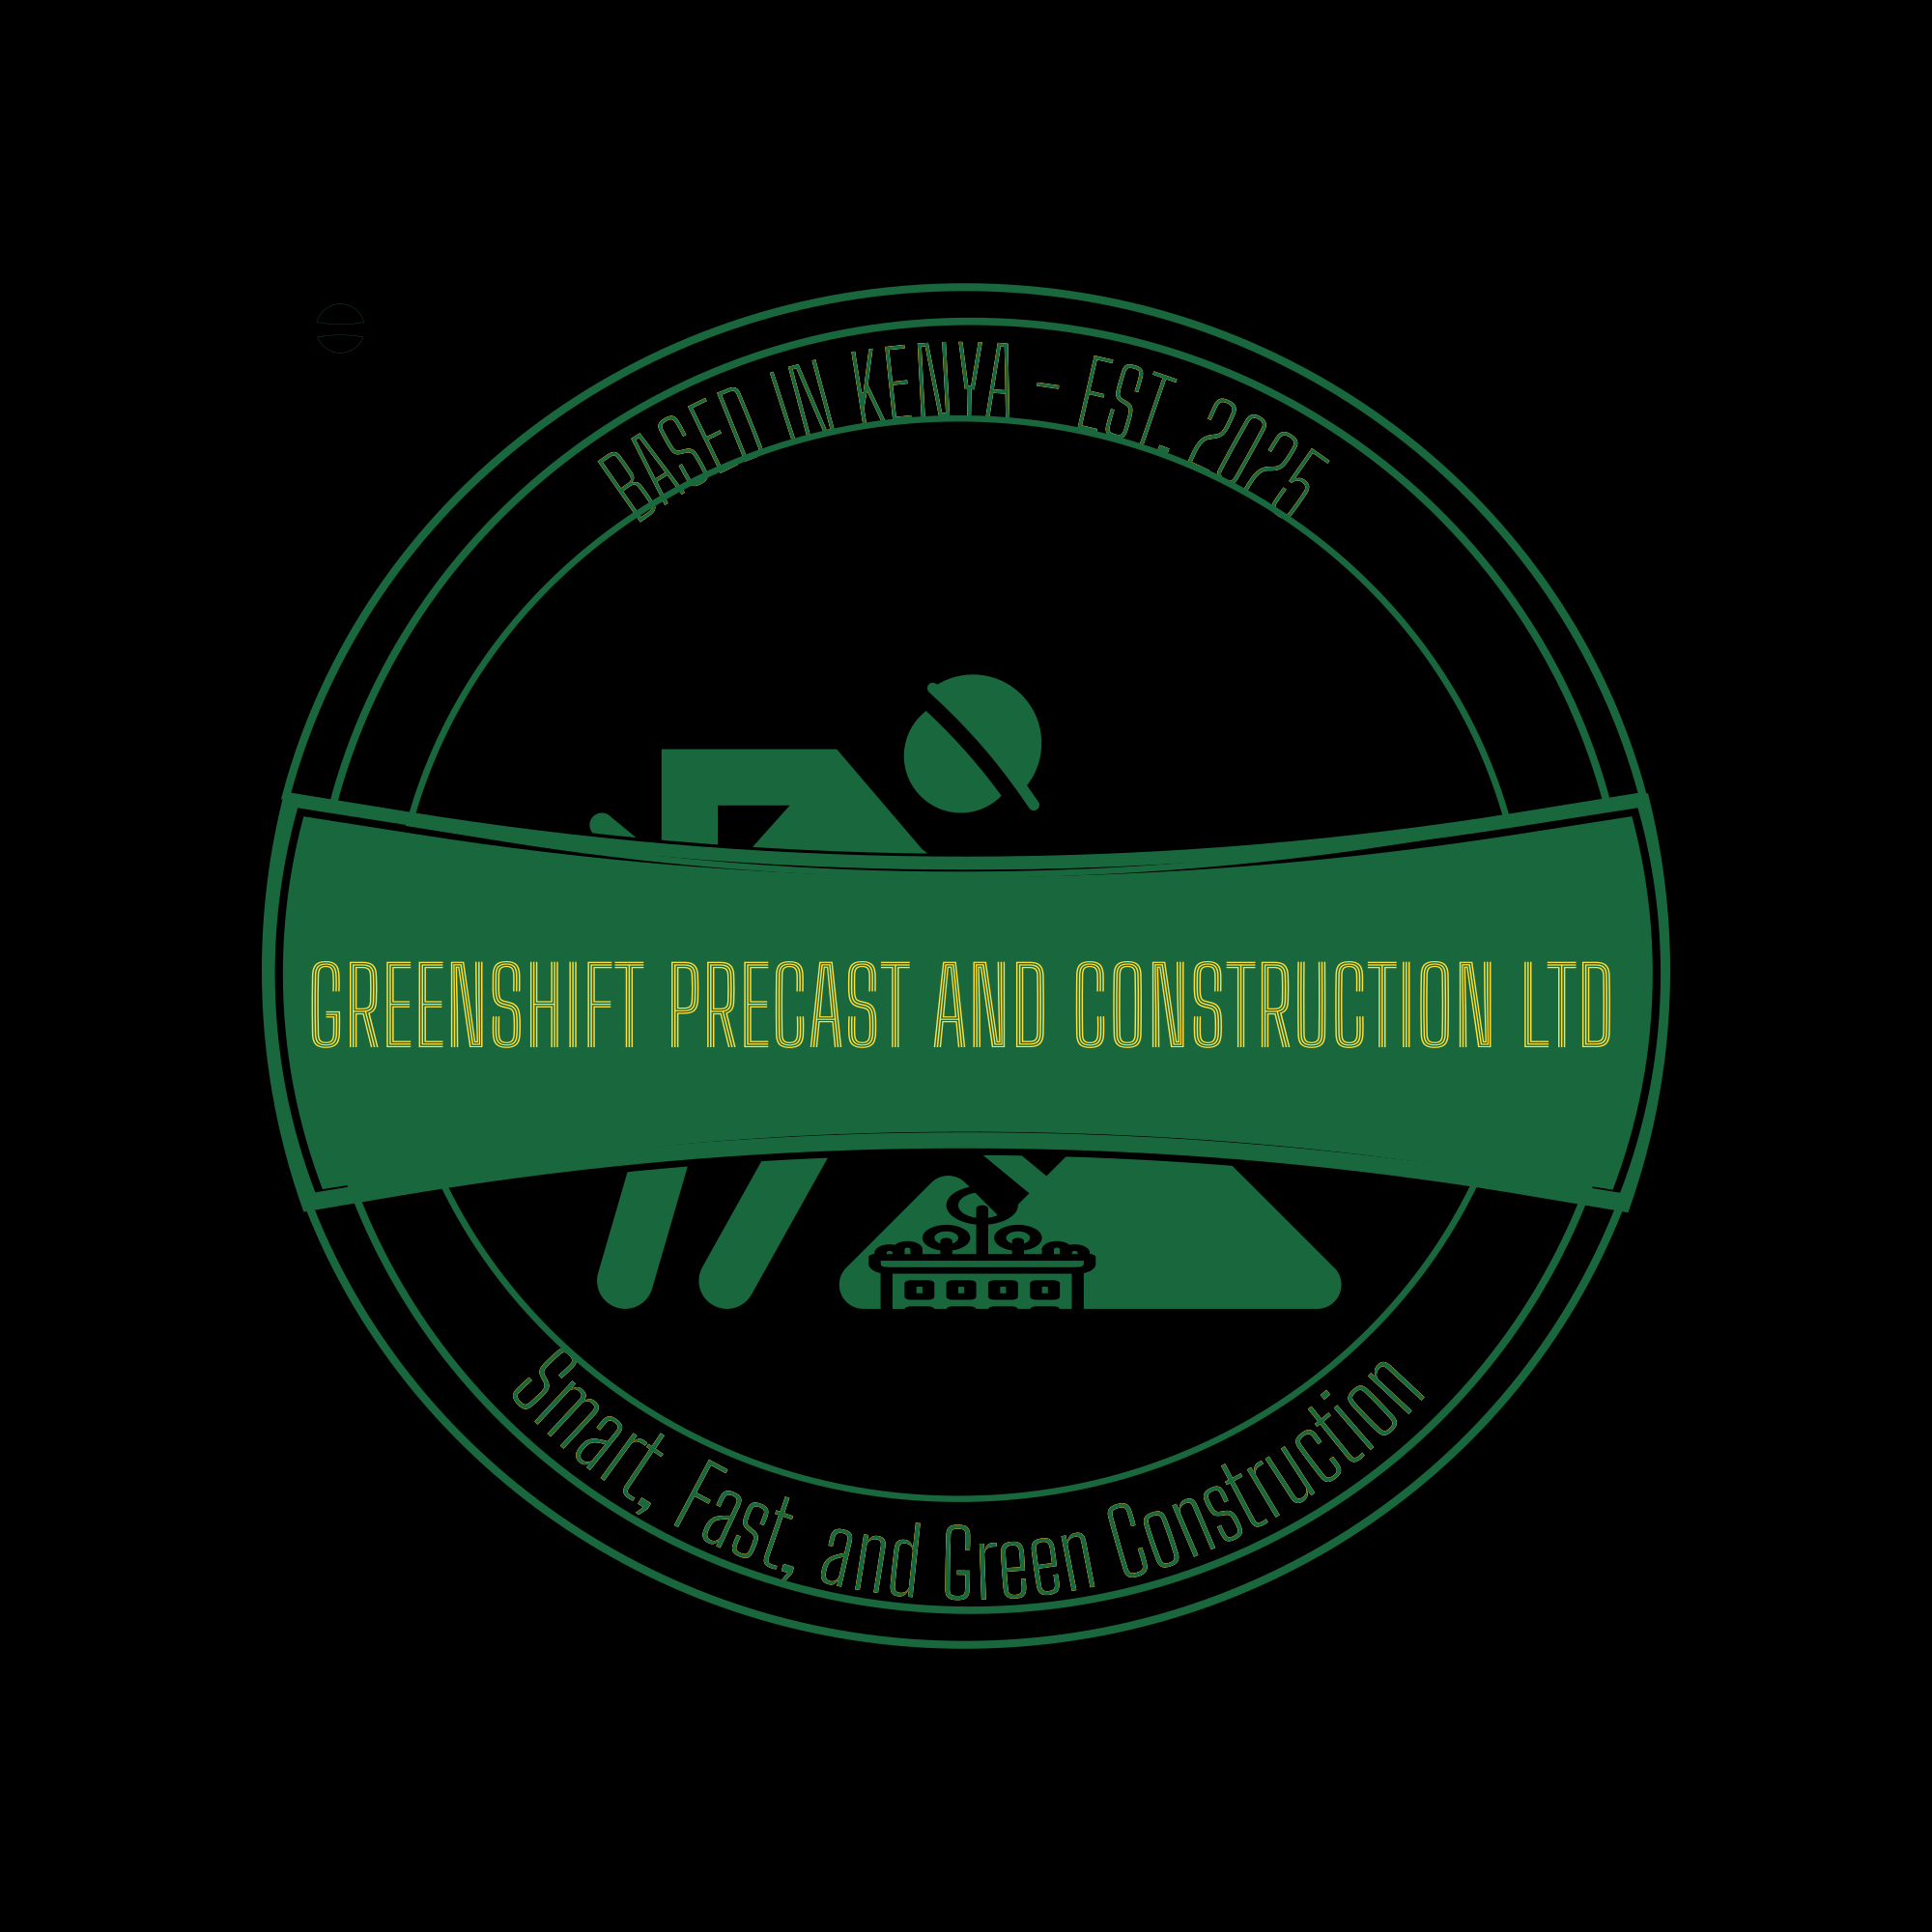

Business Plan: Greenshift Precast and Construction Ltd

Executive Summary
Greenshift Precast and Construction Ltd is a Kiambu-based startup specializing in smart, fast, and green construction using precast technology. The company seeks to serve homeowners and small developers with modern and sustainable housing solutions. With an initial capital of under KES 300,000, the business will start small-scale, focusing on residential units, cabro works, and landscape-integrated construction.

Company Description
Registered as a private limited company in Kenya, Greenshift Precast and Construction Ltd combines structural engineering innovation with landscape design expertise. Our approach emphasizes affordability, speed, and environmental responsibility.

Market Analysis
The Kenyan construction industry is rapidly expanding, with a growing demand for affordable housing. Kiambu County, part of the Nairobi Metropolitan region, provides a strategic location for residential projects. Precast construction is gaining traction as a cost-effective alternative to traditional methods. Target customers include homeowners, developers, and real estate cooperatives seeking efficient solutions.

Marketing Strategy
• Social media marketing (Facebook, Instagram, TikTok)
• Referrals through satisfied clients
• Collaboration with local architects and quantity surveyors
• On-site branding with banners and flyers
• Offering free consultations for first-time clients

Operational Plan
The company will operate from a small yard in Kiambu where precast elements (wall panels, slabs, cabros) will be produced. Labor will be a mix of skilled and semi-skilled workers hired per project. Essential tools and molds will be locally fabricated to minimize startup costs.

Startup Capital and Financial Plan
Initial investment: KES 300,000 (target)
Breakdown:
• Molds, tools, and equipment – 120,000
• Raw materials (cement, sand, steel, aggregates) – 70,000
• Site rent and utilities – 30,000
• Branding, registration, and marketing – 40,000
• Contingency and working capital – 40,000

Revenue Sources
• Precast wall and slab sales
• Residential house construction contracts
• Landscaping and cabro works
• Consultancy and design services

Growth Plan (6-Month Roadmap)
Month 1–2: Registration, branding, and setup of small precast yard
Month 3–4: Pilot residential project and social media campaigns
Month 5–6: Expand client base and introduce eco-friendly product line (e.g., solar-integrated precast roofs)

Conclusion
Greenshift Precast and Construction Ltd aims to be a symbol of smart, affordable, and sustainable construction in Kenya. By combining landscape architecture and precast innovation, the company is set to transform modern building practices in the region.

